**מעבדה 3:**

מגישים:

איילון בן סימון – 312162951

סער ויקטור – 312392822

תרגיל 1 (פלט):

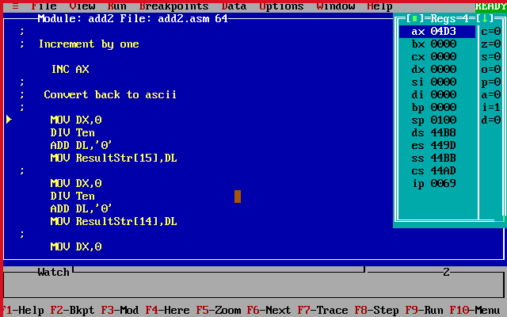

1234+1=1235

16^0*3+16^1*13+16^2*4=1235

תרגיל 2 (קוד):

; Lab3.asm

;

.MODEL SMALL

.STACK 100h

.DATA

temp DW 0

Ten DW 10

number DW 0

sumnum DW 0

reVSumnum DW 0

PromptStr DB 'Please enter (from 1000 up to 9999):',13,10,'$'

errMsg DB ' Wrong',13,10,'$'

harshadMsg DB ' Harshad Number',13,10,'$'

SpharshadMsg DB 'It Is Also A Special Harshad number',13,10,'$'

NoharshadMsg DB ' Is Not Harshad Numbers' ,13,10, '$'

resultStr DB ,13,10, 'XXXX' ,13,10, '$'

;

.CODE

.386

MOV AX,@DATA ; DS can be written to only through a register

MOV DS,AX ; Set DS to point to data segment

MOV AH,9 ; Set print option for int 21h

MOV DX,OFFSET PromptStr ; Set DS:DX to point to PromptString

INT 21h ; Print PromptStr

;scan character to AL

MOV AH,1

INT 21h

MOV resultStr[2],AL ;build the num as a string

; Read first digit

SUB AL,'0' ;convert to number

MOV AH,0

MOV sumnum,AX

MUL Ten ;AX=AX*10

MOV number,AX

MOV AX,0

; Read second digit

;scan character to AL

MOV AH,1

INT 21h

MOV resultStr[3],AL ;build the num as a string

SUB AL,'0' ;convert to number

MOV AH,0

ADD sumnum,AX

ADD AX,number ;AX=AX+number

MUL Ten ;AX=AX*10

MOV number,AX

MOV AX,0

; Read third digit

;scan character to AL

MOV AH,1

INT 21h

MOV resultStr[4],AL ;build the num as a string

SUB AL,'0';convert to number

MOV AH,0

ADD sumnum,AX

ADD AX,number ;AX=AX+number

MUL Ten ;AX=AX*10

MOV number,AX

MOV AX,0

; Read fourth digit

;scan character to AL

MOV AH,1

INT 21h

MOV resultStr[5],AL ;build the num as a string

;check if one of the digits is illegal

;illegal is digit>=0 && digit<=9

CMP resultStr[2],'1'

JB endprog

CMP resultStr[2],'9'

JA endprog

CMP resultStr[3],'0'

JB endprog

CMP resultStr[3],'9'

JA endprog

CMP resultStr[4],'0'

JB endprog

CMP resultStr[4],'9'

JA endprog

CMP resultStr[5],'0'

JB endprog

CMP resultStr[5],'9'

JA endprog

SUB AL,'0' ;convert to number

MOV AH,0

ADD sumnum,AX ;sumnum=sumnum+AX

;check if the sum of digits is 1-9

ADD AX,number

MOV number,AX

CMP sumnum,9

JBE onedDigit

;check if the division is a fractions

MOV DX,0

DIV sumnum ;dx:ax=dx=שארית

;ax=שלם

CMP DL,0

JNE notharshad

;building the reVSumnum

MOV AX,sumnum

MOV DX,0

DIV Ten

MOV reVSumnum,DX

MOV DX,AX

MOV AX, reVSumnum

MOV temp,DX

MUL Ten

ADD AX,temp

MOV reVSumnum,AX

MOV AX,number

MOV DX,0

DIV reVSumnum

CMP DL,0

JE spharshad

JMP harshad

;print notharshad to screen

onedDigit:

MOV AX,number

MOV DX,0

DIV sumnum

CMP DL,0

JE spharshad

notharshad:

MOV DX,OFFSET NoharshadMsg

MOV AH,9

INT 21h

JMP endprog1

;print harshad to screen

harshad:

MOV DX,OFFSET harshadMsg

MOV AH,9

INT 21h

JMP endprog1

;print spharshad to screen

spharshad:

MOV DX,OFFSET harshadMsg

MOV AH,9

INT 21h

MOV DX,OFFSET SpharshadMsg

MOV AH,9

INT 21h

JMP endprog1

;print error msg to screen

endprog:

MOV DX,OFFSET errMsg

MOV AH,9

INT 21h

;end of the program

endprog1:

MOV AH,4Ch

INT 21h

END

**פלט 1:**

